Project Design Phase-I

Solution Architecture

|  |  |
| --- | --- |
| Date | 06.10.2022 |
| Team ID | PNT2022TMID08073 |
| Project Name | News tracker Application |
| Maximum marks | 4 marks |

Solution Architecture:

Solution architecture is a complex process – with many sub-processes – that bridges the gap between business problems and technology solutions. Its goals are to:

• Find the best tech solution to solve existing business problems.

• Describe the structure, characteristics, behaviour, and other aspects of the software to project stakeholders.

• Define features, development phases, and solution requirements.

• Provide specifications according to which the solution is defined, managed, and delivered.

SOLUTION ARCHITECTURE

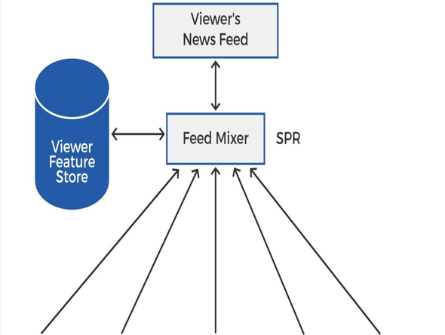FPRs

    

JOBS ARTICLES FOLLOW FEED ADS NEWS

